

Futures & Options

**Circular No:** MCCIL/EDS/2245/2022 15th July 2022

**Sub: EDS Settlement Schedule for August 2022**

In terms of the provisions of the Rules, Byelaws and Regulations of the Clearing Corporation, Clearing Members are hereby notified as under:

The Settlement schedule for the month of August 2022 will be as follows:

|  |  |
| --- | --- |
| **Trade Date** | **Settlement Date** |
| 01-Aug-22 | 02-Aug-22 |
| 02-Aug-22 | 03-Aug-22 |
| 03-Aug-22 | 04-Aug-22 |
| 04-Aug-22 | 05-Aug-22 |
| 05-Aug-22 | 08-Aug-22 |
| 08-Aug-22 | 10-Aug-22 |
| 10-Aug-22 | 11-Aug-22 |
| 11-Aug-22 | 12-Aug-22 |
| 12-Aug-22 | 17-Aug-22 |
| 16-Aug-22 | 17-Aug-22 |
| 17-Aug-22 | 18-Aug-22 |
| 18-Aug-22 | 19-Aug-22 |
| 19-Aug-22 | 22-Aug-22 |
| 22-Aug-22 | 23-Aug-22 |
| 23-Aug-22 | 24-Aug-22 |
| 24-Aug-22 | 25-Aug-22 |
| 25-Aug-22 | 26-Aug-22 |
| 26-Aug-22 | 29-Aug-22 |
| 29-Aug-22 | 30-Aug-22 |
| 30-Aug-22 | 01-Sep-22 |

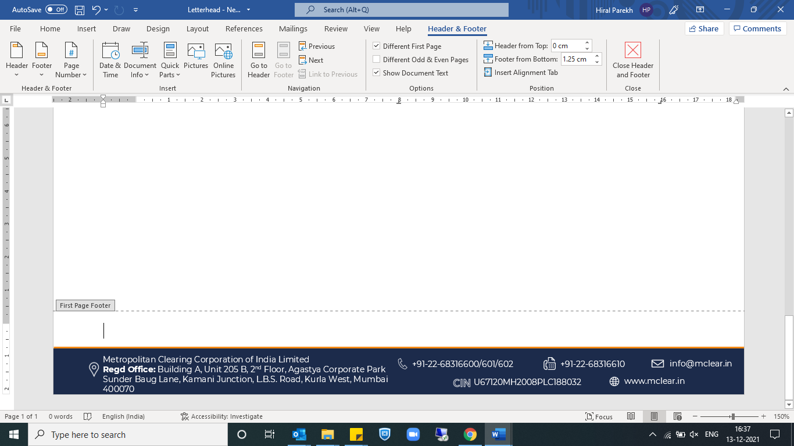

Timings for the Pay-in and Pay-out of funds on the respective settlement date shall be as under:

|  |  |
| --- | --- |
| **Activity** | **Time** |
| Pay-in of Funds: T+1 basis | By 8:30 AM |
| Pay-out of Funds | After 11:30 AM |

For clarifications, members may contact Customer Service on **022-68316600** or send an email to **info@mclear.in**

For and on behalf of

**Metropolitan Clearing Corporation of India Limited**

**Shweta Bhatt**

**Sr. Manager**

